**Sheet No : 5**

**Assignment No : 8**

**Write a pl/sql block for the following:**

1. **Insert data into a table containing two attributes namely radius & circumference of circles. You may get different values of radius either from keyboard or you may generate different values.**

**Creation of table:**

create table circle (

radius number,

circumference number

);

**Pl/sql block to insert values into table circle:**

declare

z number;

begin

for i in 1..50 loop

z := 100*dbms_random.value();

insert into circle values(z,2*3.14*z);

end loop;

end;

/

select * from circle

/

**Result:**

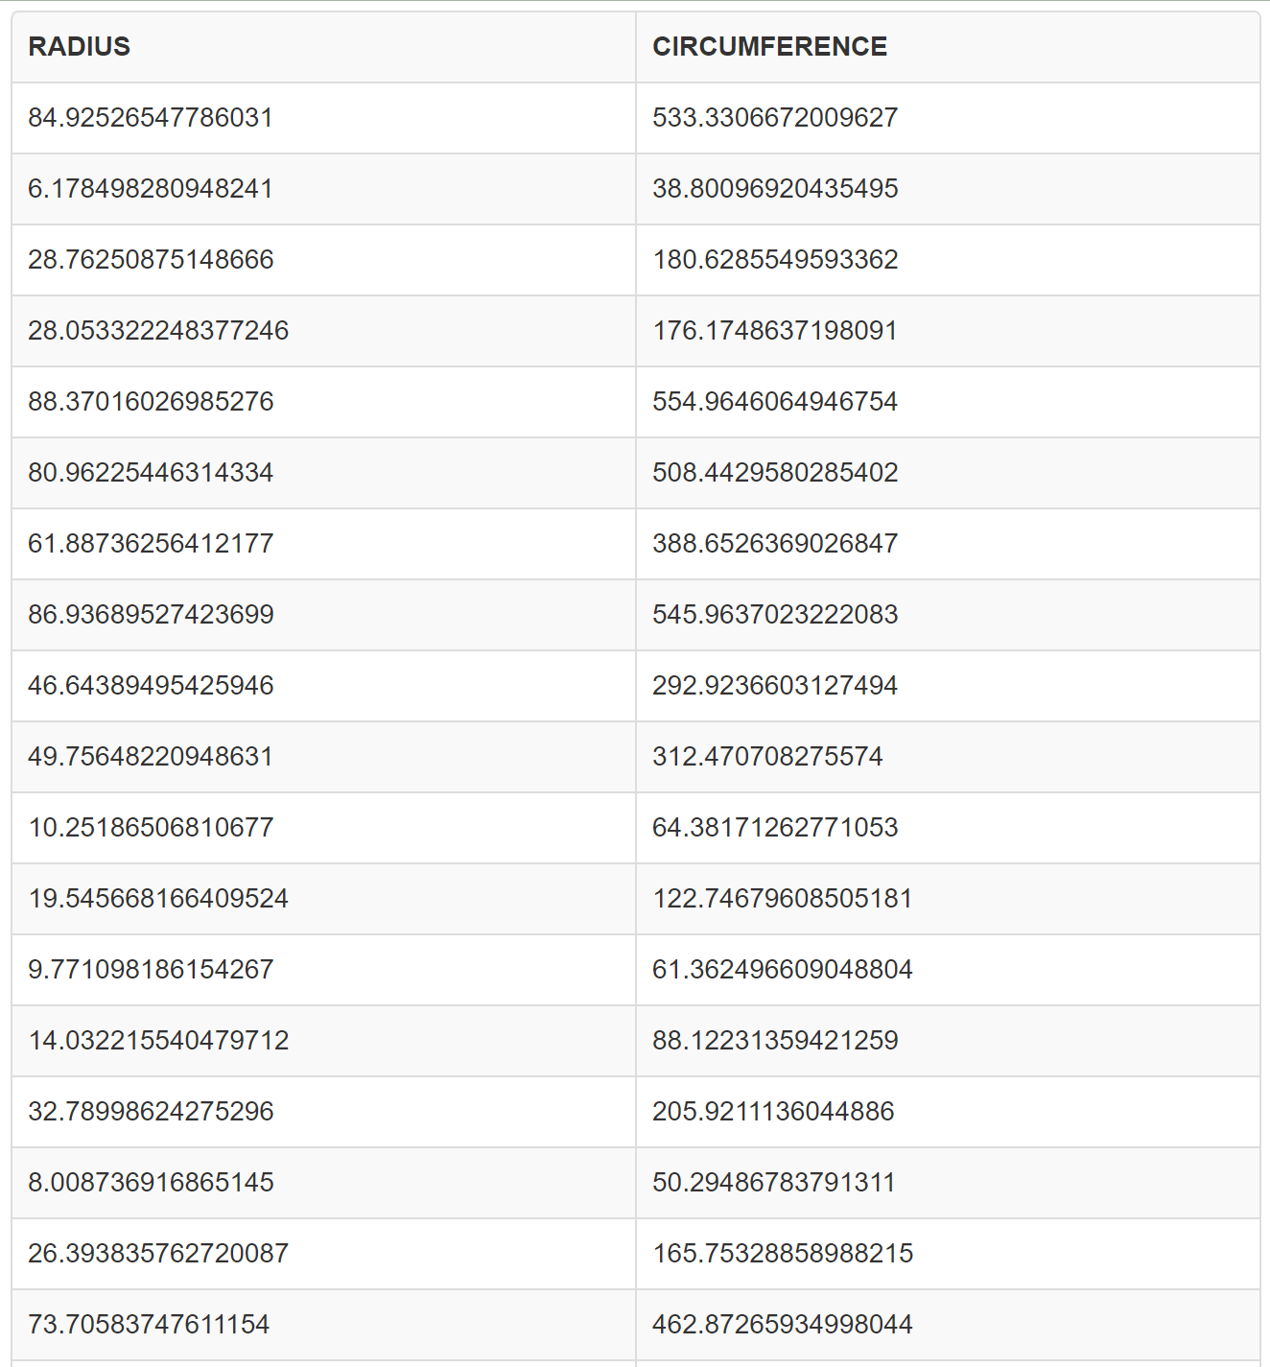

1. **Update the balance of each customer from a cust_acct table showing withdrawal of Rs.1000/- as service charge provided that the customer balance shows at least Rs.1000/-.**

**Creation of table:**

create table cust_acct (

cust_id number primary key,

balance number

);

**Snapshot of the table:**

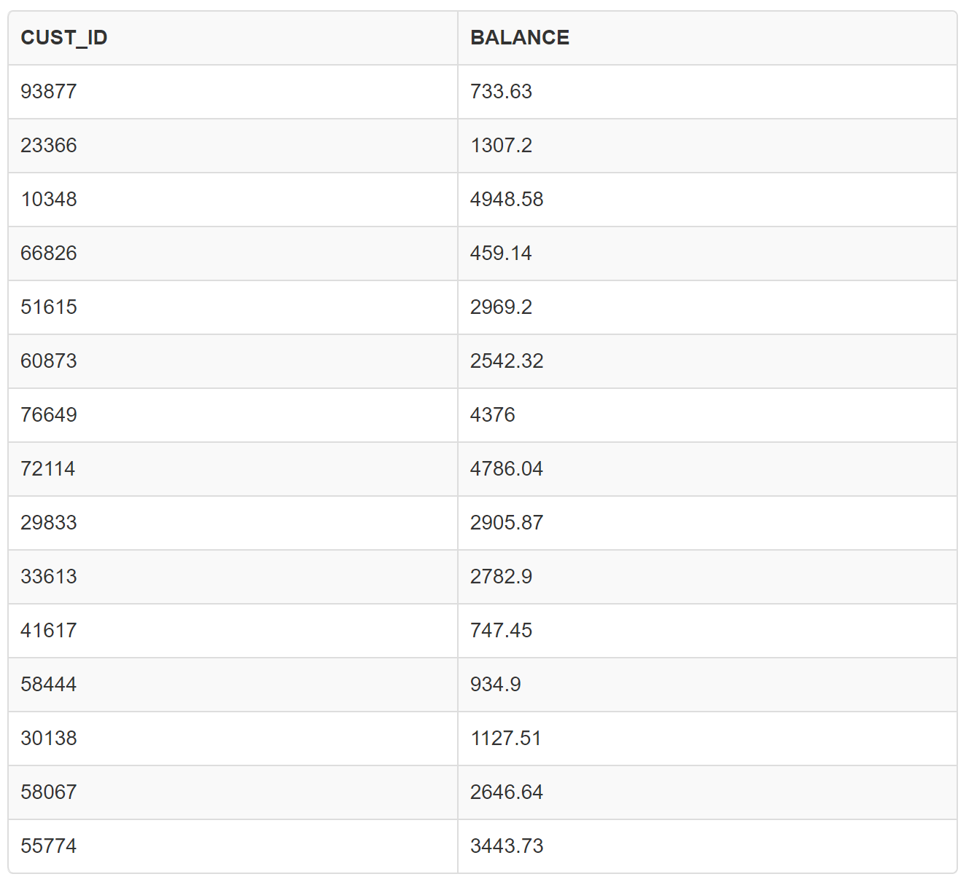

**Pl/sql block for updation:**

declare

begin

update cust_acct

set balance = balance - 1000

where balance >= 1000;

commit;

dbms_output.put_line('balances updated successfully.');

exception

when others then

dbms_output.put_line('an error occurred while updating balances.');

end;

/

**Table after updation:**

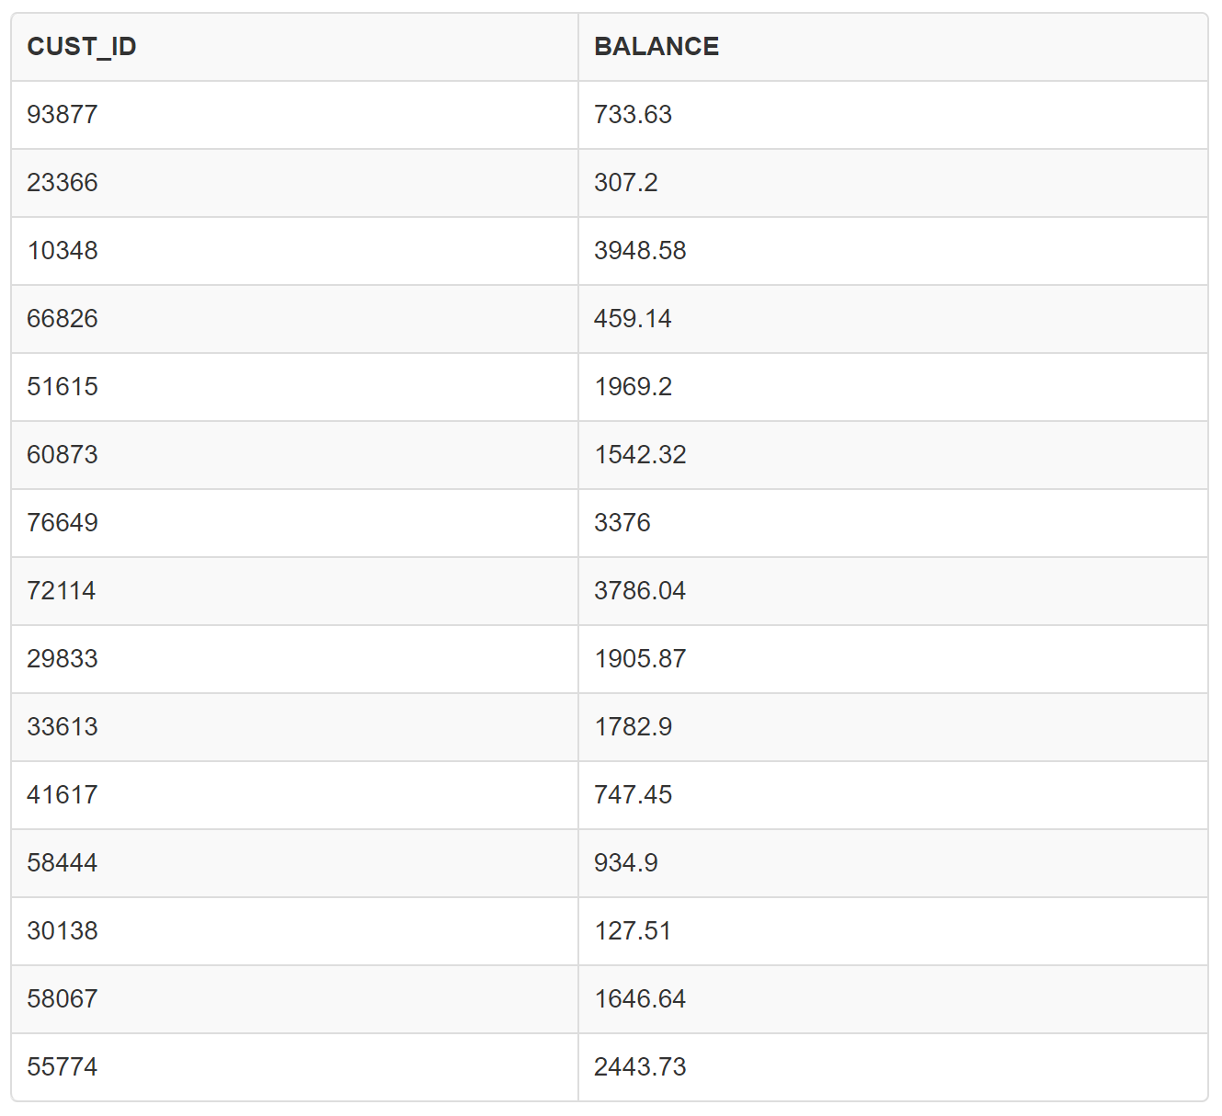

1. **Update the salary of each employee from EMP table by 15% using cursor.**

**Creation of table EMP:**

create table emp (

emp_id number primary key,

salary number

);**­­­­**

**Snapshot of the table:**

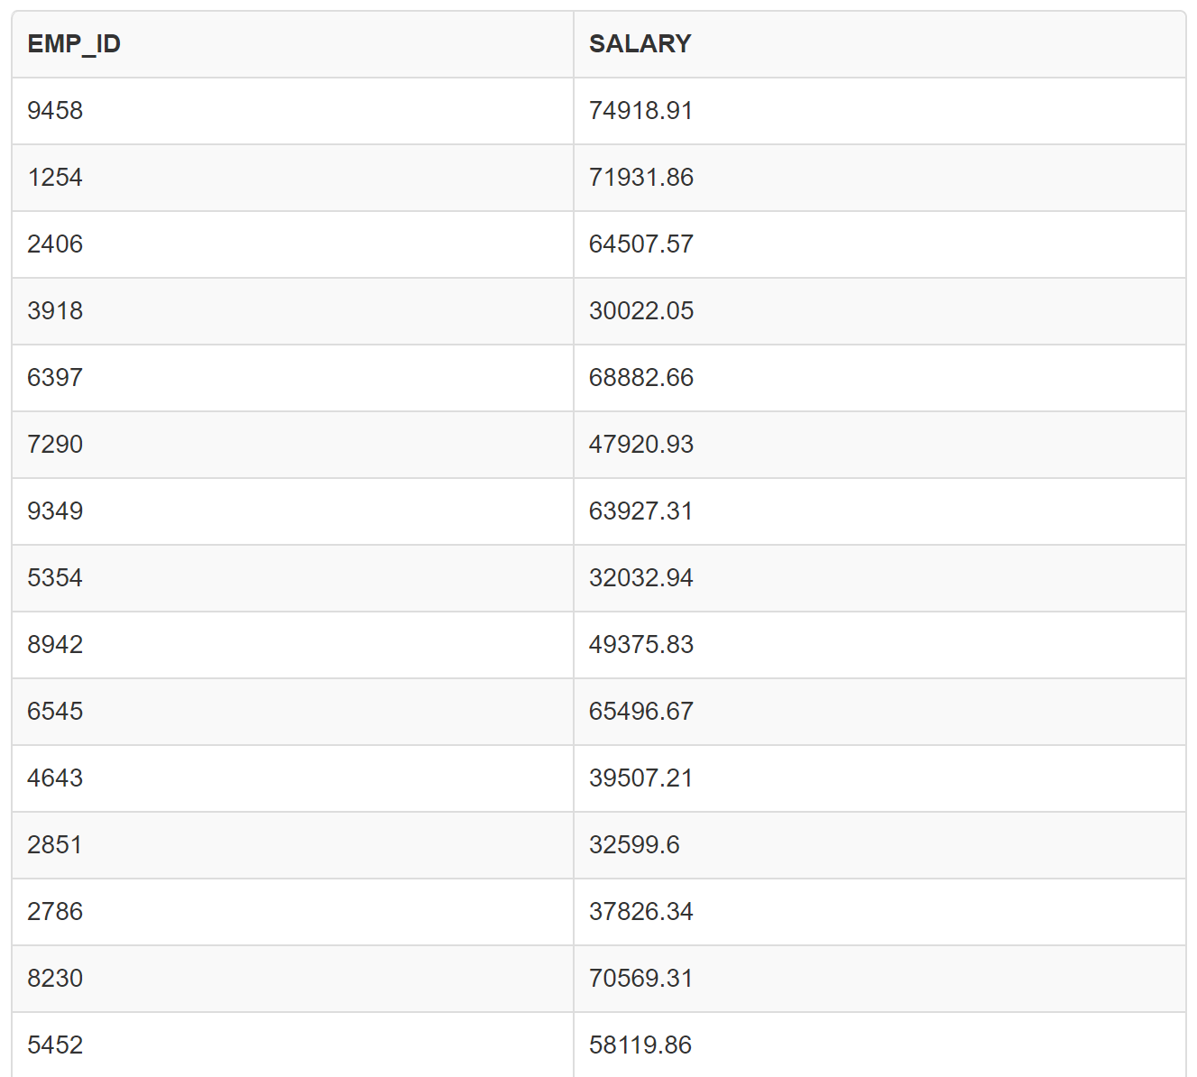

**Pl/sql block for updation:**

declare

cursor emp_cursor is

select emp_id, salary

from emp;

v_emp_id emp.emp_id%type;

v_salary emp.salary%type;

begin

for emp_rec in emp_cursor loop

v_emp_id := emp_rec.emp_id;

v_salary := emp_rec.salary * 1.15;

update emp

set salary = v_salary

where emp_id = v_emp_id;

end loop;

commit;

dbms_output.put_line('salaries updated successfully.');

exception

when others then

dbms_output.put_line('an error occurred while updating salaries.');

end;

/

**Table after updation:**

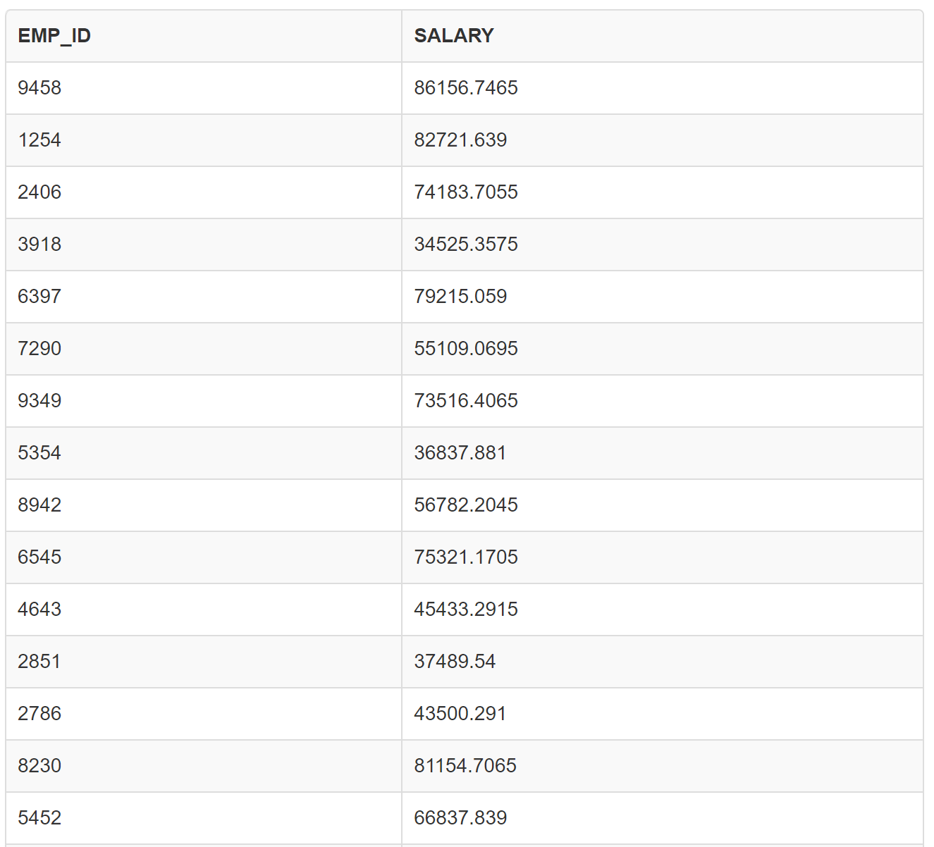

1. **Update the balance in the ITEM_MSTR table each time a transaction takes place in the ITEM_TR table. If this item_id is already present in the ITEM_MSTR table an update is performed to decrease the balance by the quantity specified in the ITEM_TR table. If the item_id is not present in the ITEM_MSTR table, the tuple is to be inserted.**

**Creation of table ITEM_MSTR:**

create table item_mstr (

item_id number primary key,

balance number

);

**Snapshot of table ITEM_MSTR:**

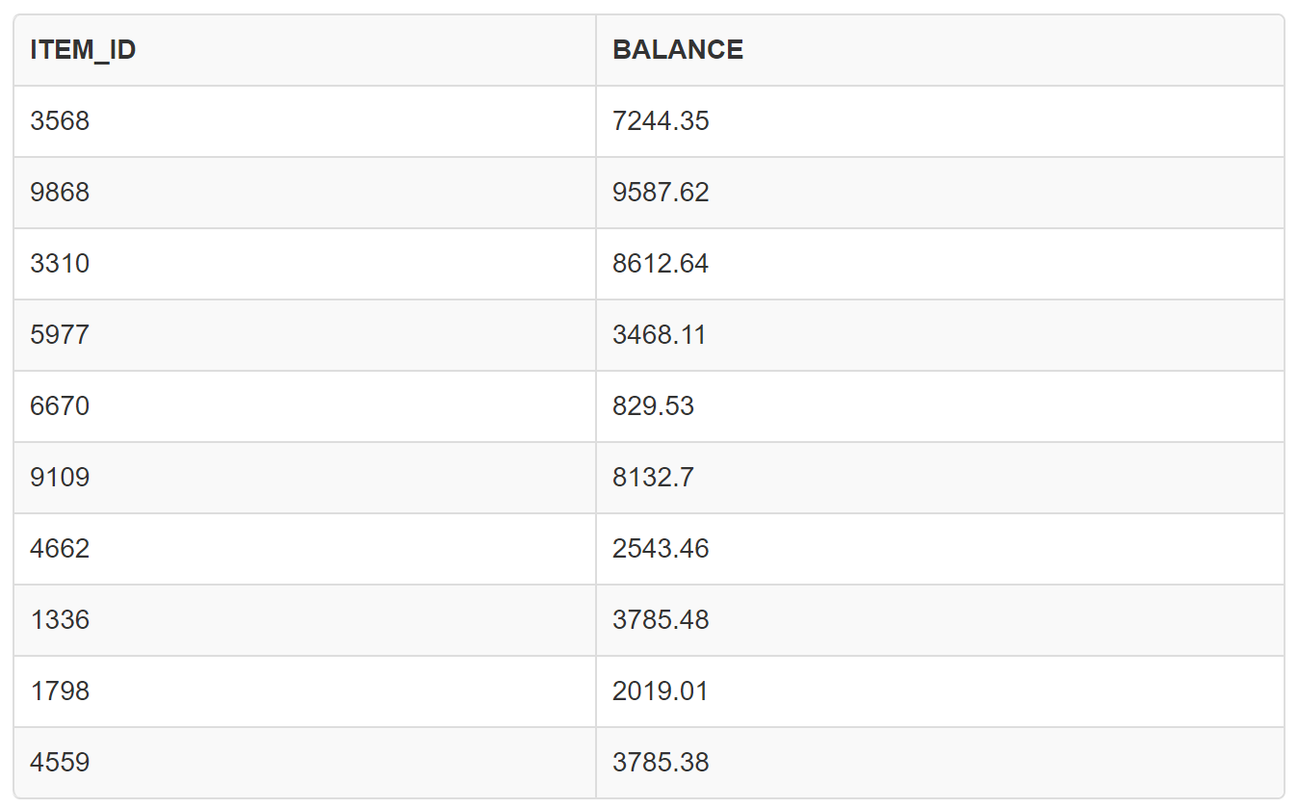

**Creation of table ITEM_TR:**

create table item_tr (

trans_id number primary key,

item_id number,

quantity number

);

**Snapshot of table ITEM_TR:**

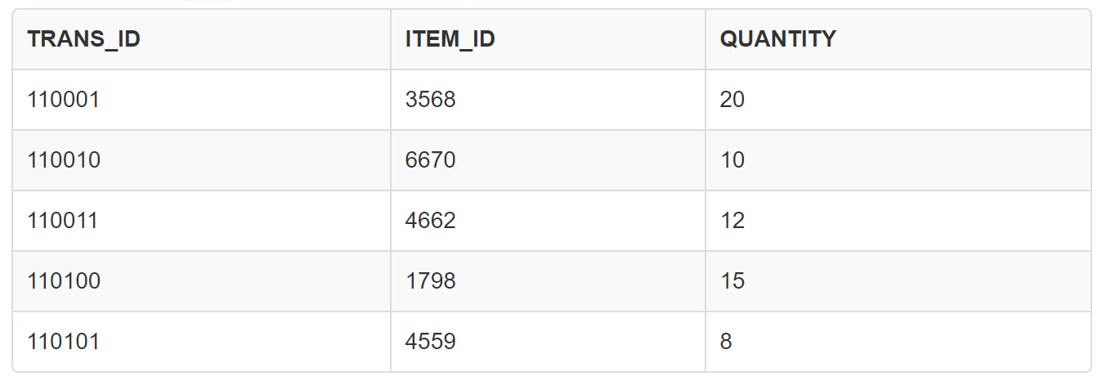

**Pl/sql block to update tables:**

declare

v_item_id number;

v_quantity number;

v_balance number;

begin

for trans_rec in (select item_id, quantity from item_tr) loop

v_item_id := trans_rec.item_id;

v_quantity := trans_rec.quantity;

-- check if the item_id exists in item_mstr.

select balance into v_balance

from item_mstr

where item_id = v_item_id;

if v_balance is not null then

-- item exists, update the balance.

update item_mstr

set balance = balance - v_quantity

where item_id = v_item_id;

else

-- item doesn't exist, insert a new record.

insert into item_mstr (item_id, balance) values (v_item_id, -v_quantity);

end if;

end loop;

commit;

dbms_output.put_line('balances updated in item_mstr table.');

exception

when others then

dbms_output.put_line('an error occurred while updating balances.');

end;

/

**Table after updation:**

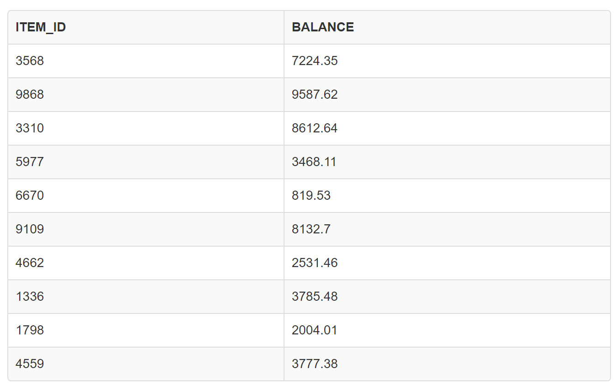

1. **Write a PROCEDURE for raising salary of some employee by some amount. The PROCEDURE to be written may carry two parameters emp_id and amt to be raised. Include two exceptions which will be raised when either emp_id is not present or salary is NULL.**

**Creation of table:**

create table employees (

employee_id number,

employee_name varchar2(50),

salary number

);

**Snapshot of the table:**

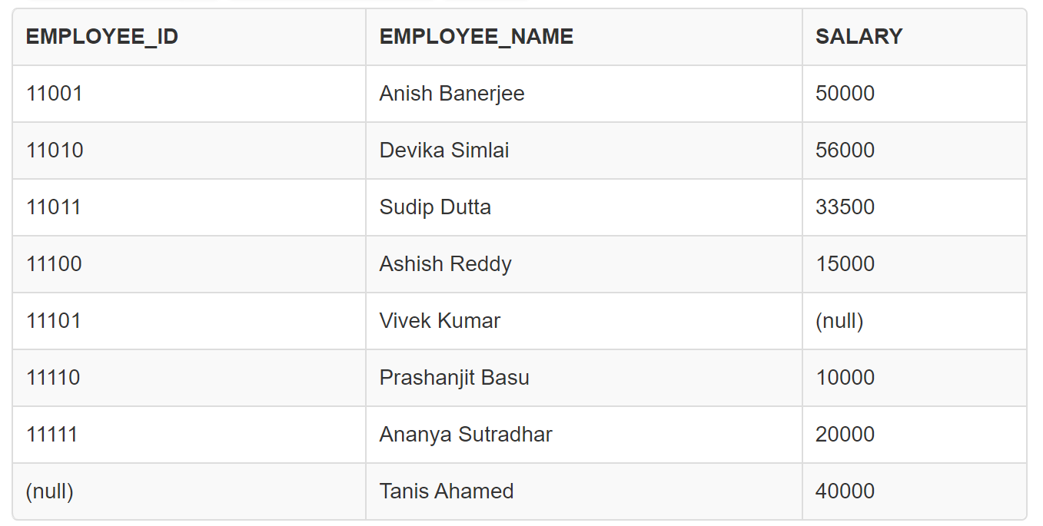

**Procedure to raise salary:**

CREATE OR REPLACE PROCEDURE raise_salary(p_emp_id IN NUMBER, p_amt IN NUMBER) IS

v_salary NUMBER;

BEGIN

SELECT salary INTO v_salary

FROM employees

WHERE employee_id = p_emp_id;

IF v_salary IS NULL THEN

RAISE_APPLICATION_ERROR(-20001, 'Employee ID not found.');

END IF;

IF v_salary + p_amt IS NULL THEN

RAISE_APPLICATION_ERROR(-20002, 'Cannot raise salary. Current salary is NULL.');

END IF;

UPDATE employees

SET salary = salary + p_amt

WHERE employee_id = p_emp_id;

COMMIT;

DBMS_OUTPUT.PUT_LINE('Salary raised successfully.');

EXCEPTION

WHEN NO_DATA_FOUND THEN

RAISE_APPLICATION_ERROR(-20001, 'Employee ID not found.');

WHEN OTHERS THEN

RAISE_APPLICATION_ERROR(-20000, 'An error occurred: ' || SQLCODE || ' - ' || SQLERRM);

END raise_salary;

/

**Calling the procedure - I:**

begin

raise_salary(11001, 5000);

end;

/

select* from employees

/

**Update in the table:**

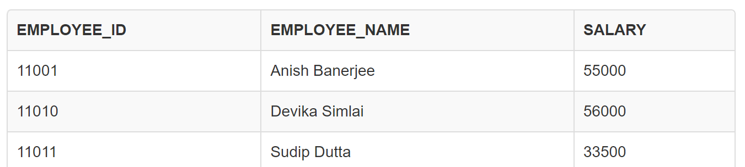

**Calling the procedure - II:**

begin

raise_salary(11010, 4000);

end;

/

select * from employees

/

**Update in the table:**

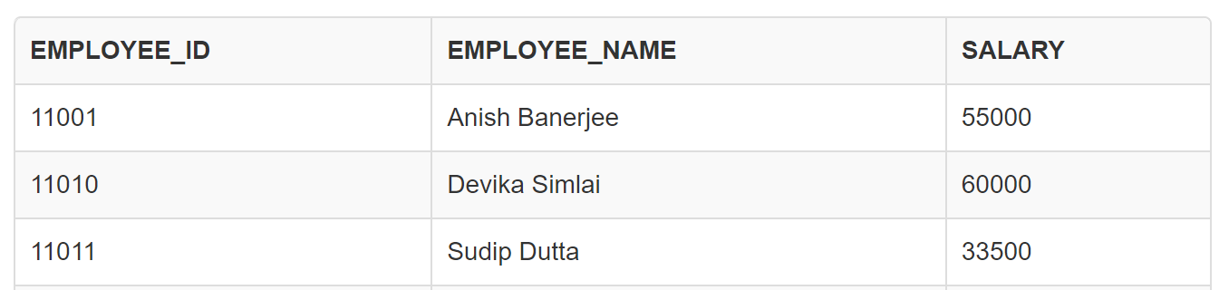

**Calling the procedure where salary is null:**

begin

raise_salary(11101, 5000);

end;

/

select * from employees

/

**Update in the table:**

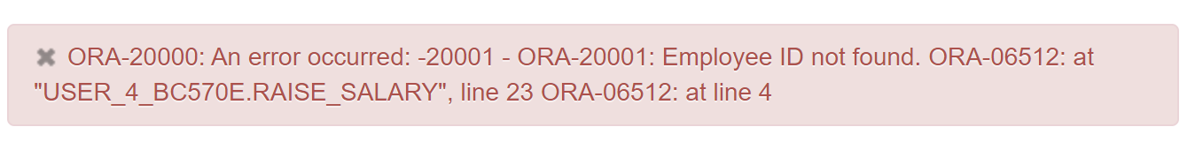

**Calling the procedure where employee_id is null:**

begin

raise_salary(11000, 5000);

end;

/

select * from employees

/

**Update in the table:**

